**PIZZA SALES SQL QUERIES**

**A. KPI’s**

**1. Total Revenue:**

SELECT SUM(total_price) AS Total_Revenue FROM pizza_sales;

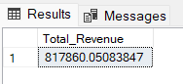

**2. Average Order Value**

SELECT (SUM(total_price) / COUNT(DISTINCT order_id)) AS Avg_order_Value FROM pizza_sales

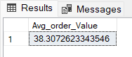

**3. Total Pizzas Sold**

SELECT SUM(quantity) AS Total_pizza_sold FROM pizza_sales

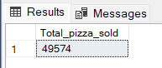

**4. Total Orders**

SELECT COUNT(DISTINCT order_id) AS Total_Orders FROM pizza_sales

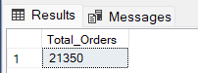

**5. Average Pizzas Per Order**

SELECT CAST(CAST(SUM(quantity) AS DECIMAL(10,2)) /

CAST(COUNT(DISTINCT order_id) AS DECIMAL(10,2)) AS DECIMAL(10,2))

AS Avg_Pizzas_per_order

FROM pizza_sales

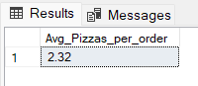

**B. Daily Trend for Total Orders**SELECT DATENAME(DW, order_date) AS order_day, COUNT(DISTINCT order_id) AS total_orders

FROM pizza_sales

GROUP BY DATENAME(DW, order_date)

***Output:***

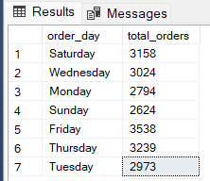

**C. Hourly Trend for Orders**

SELECT DATEPART(HOUR, order_time) as order_hours, COUNT(DISTINCT order_id) as total_orders

from pizza_sales

group by DATEPART(HOUR, order_time)

order by DATEPART(HOUR, order_time)

***Output***

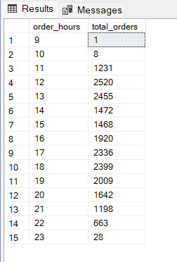

**D. % of Sales by Pizza Category**

SELECT pizza_category, CAST(SUM(total_price) AS DECIMAL(10,2)) as total_revenue,

CAST(SUM(total_price) * 100 / (SELECT SUM(total_price) from pizza_sales) AS DECIMAL(10,2)) AS PCT

FROM pizza_sales

GROUP BY pizza_category

***Output***

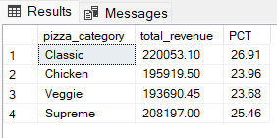

**E. % of Sales by Pizza Size**

SELECT pizza_size, CAST(SUM(total_price) AS DECIMAL(10,2)) as total_revenue,

CAST(SUM(total_price) * 100 / (SELECT SUM(total_price) from pizza_sales) AS DECIMAL(10,2)) AS PCT

FROM pizza_sales

GROUP BY pizza_size

ORDER BY PCT DESC

***Output***

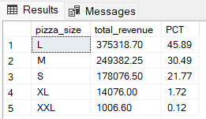

**F. Total Pizzas Sold by Pizza Category**

SELECT pizza_category, SUM(quantity) as Total_Quantity_Sold

FROM pizza_sales

GROUP BY pizza_category

***Output***

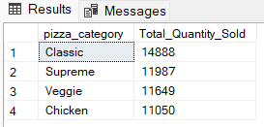

**G. Top 5 Best Sellers by Total Pizzas Sold**

SELECT Top 5 pizza_name, SUM(quantity) AS Total_Pizza_Sold

FROM pizza_sales

GROUP BY pizza_name

ORDER BY Total_Pizza_Sold DESC

***Output***

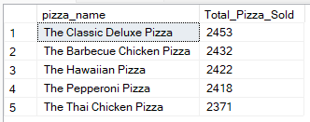

**H. Bottom 5 Best Sellers by Total Pizzas Sold**

SELECT TOP 5 pizza_name, SUM(quantity) AS Total_Pizza_Sold

FROM pizza_sales

GROUP BY pizza_name

ORDER BY Total_Pizza_Sold ASC

***Output***

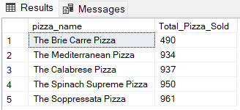

***NOTE***

If you want to apply the Month, Quarter, Week filters to the above queries you can use WHERE clause. Follow some of below examples

SELECT DATENAME(DW, order_date) AS order_day, COUNT(DISTINCT order_id) AS total_orders

FROM pizza_sales

WHERE MONTH(order_date) = 1

GROUP BY DATENAME(DW, order_date)

*\*Here MONTH(order_date) = 1 indicates that the output is for the month of January. MONTH(order_date) = 4 indicates output for Month of April.*

SELECT DATENAME(DW, order_date) AS order_day, COUNT(DISTINCT order_id) AS total_orders

FROM pizza_sales

WHERE DATEPART(QUARTER, order_date) = 1

GROUP BY DATENAME(DW, order_date)

*\*Here DATEPART(QUARTER, order_date) = 1 indicates that the output is for the Quarter 1. MONTH(order_date) = 3 indicates output for Quarter 3.*